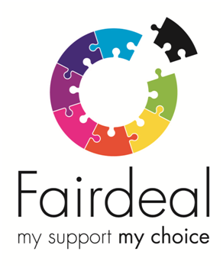

Team Leader Vacancy

Fair Deal is a social care organisation based in Glasgow who is recruiting a Team Leader to work in the Glasgow area. We are passionate about providing the people we support with the opportunity to live as independently as possible with greater choice and control.

The Team Leader role will manage and develop highly individualised support services, providing positive leadership and line management to ensure the delivery of high quality support by staff in line with individual needs, agreed outcomes, aspirations and individual budgets. The role will maintain direct contact and involvement with the people we support and will involve the management of staff resources and budgets:

35 hours per week (part-time/job share would be considered)

£28,783 pa

Closing Date — 31 August 2022

The Role

You will require the following Essential Qualifications and Experience:
- Minimum SVQ 3 in Social Services and Healthcare
- Minimum 2 years’ experience in a Social Care environment
- SSSC Registration
- Experience in supporting and developing relationships with clients and families
- Experience in liaising with social work departments and community organisations
- Line Management Experience in a Social Care Environment (desirable)
- A recognised management qualification (desirable)
- Excellent leadership and organisational skills with an ability to delegate effectively
- Excellent Microsoft knowledge
- Excellent communication and interpersonal skills
- Ability to motivate both individuals and a team
- Commitment to the ethos and values of Fair Deal
- Knowledge of regulatory requirements affecting care organisations
- Willingness to occasionally work out with office hours to meet organisational needs
- Full Driving licence and access to own car for business purposes (desirable)
Duties:
- To oversee the day to day running of the designated services
- To manage, supervise and support onsite staff
- To lead on service provision and service development
- To manage learning and development of staff
- To maintain effective communication within the team and with all relevant stakeholders

You will be required to provide on call cover at evenings and weekends.

In addition to a rewarding career, with competitive rates of pay and ongoing training, Fair Deal can offer a wide range of staff benefits including, competitive holiday entitlement, company sick pay scheme, workplace pension scheme, enhanced maternity/paternity benefits and flexible working.

For an application pack and full job descriptions visit our website www.fair-deal.org or call us on 0141 634 4996.

Note: CVs will not be accepted

