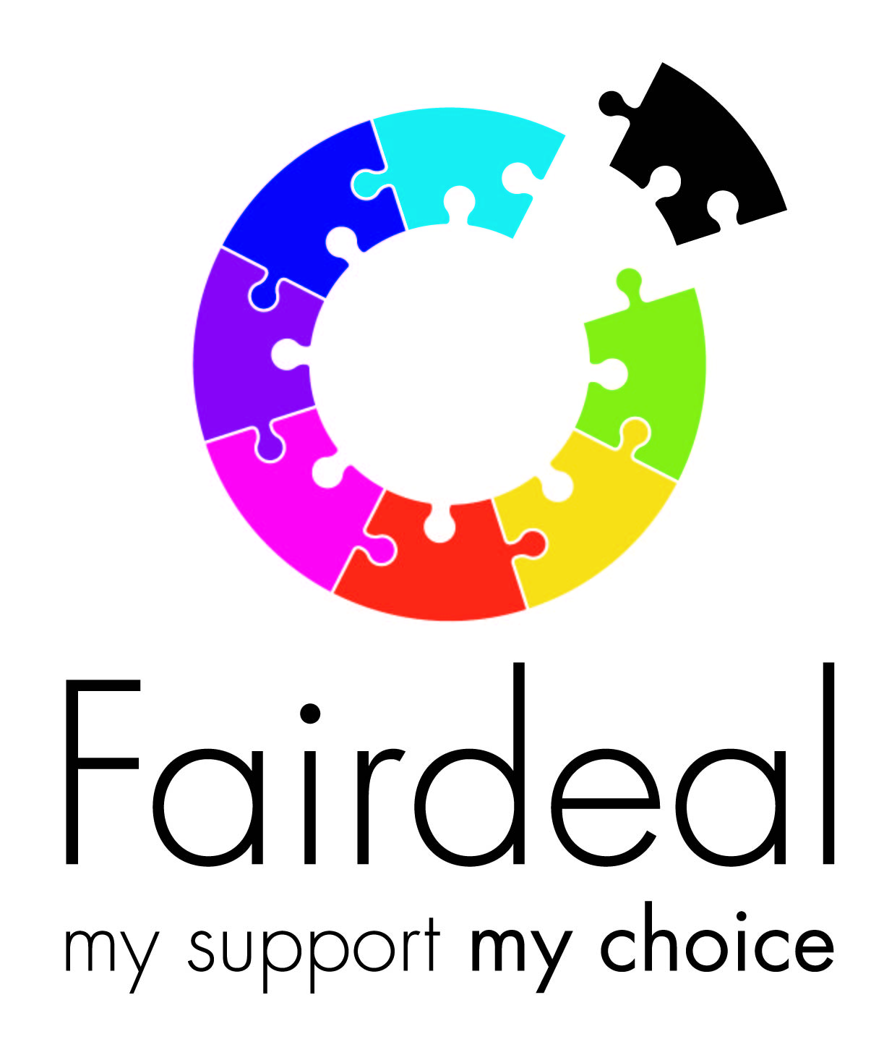

Duty of Candour Annual Report

Fair Deal must be open and honest with people who use our services and their family carers when something that goes wrong with their support, or has the potential to cause, harm or distress. Services apologise, offer appropriate remedy, or support and fully explain the effects to the person supported. As part of our responsibilities, we must produce an annual report to provide a summary of the number of times we have triggered Duty of Candour within our services.
We have a requirement to report any Duty of Candour events to the local authority commissioning and Care Inspectorate within a 24-hour period.
Duty of Candour within Fair Deal is the responsibility of the Quality and Development Manager to report back to the CEO. Any DoC events are recorded on incident reports.

Name and Address of Service | Fair Deal  355A Tormusk Road  Castlemilk  Glasgow  G45 0HF
Date of Report | 31/03/22
How have you made sure that you (and your staff) understand your responsibilities relating to the duty of candour and have systems in place to respond effectively? How have you done this? | Staff have been issued with a copy of our Duty of Candour Policy which is regularly reviewed. Leadership team are aware of reporting responsibilities.
Do you have a Duty of Candour Policy or written duty of candour procedure? | Yes
How many times have you/your service implemented the duty of candour procedure this financial year? | 1
A person died?
A person incurred permanent lessening of bodily, sensory, motor, physiologic or intellectual functions?
A person’s treatment increased?
The structure of a person’s body changed?
A person’s life expectancy shortened
A person’s sensory, motor, or intellectual functions was impaired for 28 days or more?
A person experienced pain or psychological harm for 28 days or more?
A person needed health treatment in order to prevent them dying?
A person needing health treatment in order to prevent other injuries as listed above? | x
TOTAL
Did the responsible person for triggering duty of candour appropriately follow the procedure? If not, did this result is any under or over reporting of duty of candour? | Yes
What lessons did you learn? | That increased cross auditing of services would enhance practice- this has been implemented.
What learning & improvements have been put in place as a result? | We provided additional risk assessment/management training to relevant staff.
Did this result is a change / update to your duty of candour policy / procedure? | No
How did you share lessons learned and who with? | Multi-disciplinary team and our internal leadership team via meeting.
Could any further improvements be made?
What systems do you have in place to support staff to provide an apology in a person-centred way and how do you support staff to enable them to do this? | We have a culture of openness and transparency, and we use debriefs and supervision to support staff to do this.
What support do you have available for people involved in invoking the procedure and those who might be affected? | Supervision, employee counselling service, coaching.
Please note anything else that you feel may be applicable to report.

