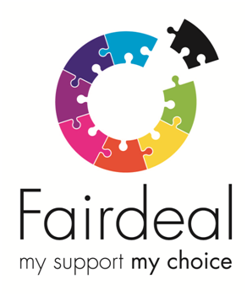

Team Leader Vacancy

Fair Deal is a social care organisation based in Glasgow who is recruiting a Team Leader to work in the Glasgow area. We are passionate about providing the people we support with the opportunity to live as independently as possible with greater choice and control.

The Team Leader role will manage and develop highly individualised support services, providing positive leadership and line management to ensure the delivery of high quality support by staff in line with individual needs, agreed outcomes, aspirations and individual budgets. The role will maintain direct contact and involvement with the people we support and will involve the management of staff resources and budgets:

35 hours per week

£25,000 to £28,783 pa

Closing Date — Friday 21st January 2022

The Role

You will require the following Essential Qualifications and Experience:
- SVQ Level 3 Social Services or equivalent qualification e.g. RMH/RNMH, Dip SW, CSS

SSSC registration

Two Years previous experience in a social care services setting with line management experience desirable

Driving Licence and car owner for business purposes required

Creative thinker and problem solver

Ability to plan and prioritise workload and motivate staff

Ability to write support plans, create staff rotas and manage budgets

Good communication skills – both written and verbal

Experience using Microsoft Office including Word, Outlook, Powerpoint and Excel

Ability to liaise effectively with a range of stakeholders and promote Fair Deal in a positive manner
Duties:
- To Oversee the day to day running of the designated services
- To manage, supervise and support onsite staff
- To lead on service provision and service development
- Manage learning and development of staff
- Maintain effective communication within the team and with all relevant stakeholders

You will be required to provide on call cover at evenings and weekends.

In addition to a rewarding career, with competitive rates of pay and ongoing training, Fair Deal can offer a wide range of staff benefits including, competitive holiday entitlement, company sick pay scheme, workplace pension scheme, enhanced maternity/paternity benefits and flexible working.

For an application pack and full job descriptions visit our website www.fair-deal.org or call us on 0141 634 4996.

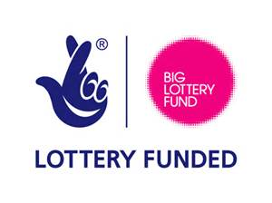
Note: CVs will not be accepted

