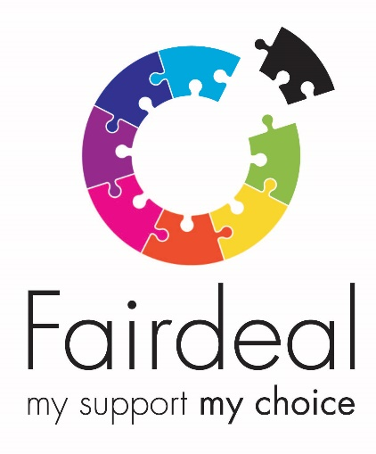

Connecting You Development Worker

Salary: £21,840 (pro rata)

Hours: 15 per week (Monday – Friday)

Closing Date: Wednesday 21st October 2020

Fair Deal recognises the vital contribution that support staff at all levels make in connecting people living with a physical or mental disability within their local community, so that they can build and maintain their independence, and access the community based projects, groups, and support they require to meet their particular outcomes.

We have an exciting opportunity for a dynamic individual to join our Connecting You Programme.

The Connecting You Development Worker role will be a central and integral role to our Connecting You programme, to ensure our Connecting You programmes will sustain, as far as possible, to ensure the programme develops and increases peoples’ independence and maximise occupancy levels at our venues/programmes, and to ensure our programme is developed and is maintained at a high standard.
- 15 hours per week (Monday to Friday)
- £12 per hour
- Closing Date — Wednesday 21st October 2020
Key Roles & Responsibilities
The key role of this post is to develop and maintain the Connecting You programme, by identifying further development opportunities to increase and maximise the Connecting You Programme city wide and in other local authority areas. The role is to ensure that people are participating fully in the programmes and are gaining maximisation from the core activities, whilst introducing new programmes that reflect the Fair Deal values and initiatives.
In addition to a rewarding career, with competitive rates of pay, Fair Deal can offer a wide range of staff benefits including, competitive holiday entitlement, company sick pay scheme, workplace pension scheme and enhanced maternity/paternity benefits.
Please visit our website www.fair-deal.org for the full job description and application form or call us on 0141 634 4996.
Completed application forms should be emailed or posted as follows:
By email: info@fair-deal.org
By post: Jill Grace, Fair Deal, 355a Tormusk Road, Glasgow, G45 0HF

