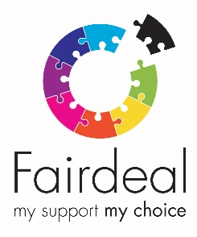
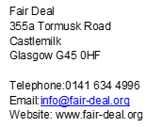

Dear Applicant,

Post Title – Business Support Coordinator
Thank you for expressing an interest in the above post. Please find enclosed further information and application details:

- Job Description x 1
- Annual Report
- Application Pack – Part A (Equal Ops Form), Part B (Application Form) and Part C (Contact Details and Data Protection Declaration)
- Fair Deal’s Vision and Mission Statement
- Fair Deal’s Values
- Criminal Convictions Declaration (only complete and bring if invited to interview)

When submitting your completed application, please include the following documentation:
- Your completed Equal Opportunities Monitoring form – Part A
- Your completed Application form – Part B
- Your completed Contact Details and Data Protection Declaration – Part C
Please do not enclose your Curriculum Vitae.
Once completed, return Part A, Part B and Part C Form to: Fair Deal, 355a Tormusk Road, Castlemilk, Glasgow, G45 0HF or by email to: info@fair-deal.org as soon as possible.
Thank you for your interest in this post, we look forward to receiving your application.

Yours sincerely

Jill Grace
Business Support Team Leader

