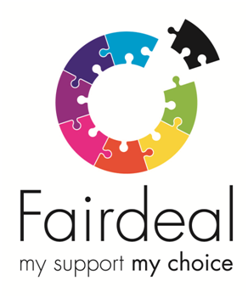

Support Worker Vacancies – Complex Support Needs Service

Fair Deal is a social care organisation based in Glasgow who is recruiting Support Workers to work in the Glasgow area. We are passionate about providing the people we support with the opportunity to live as independently as possible with greater choice and control.

We are looking to recruit a female Core Team Member* who can take on the challenging but rewarding delivery of one to one support to a female who has complex support needs.

Support Worker – Female Core Team Member*

30 and 35 hours per week vacancies

£8.75 per hour

Sleepover required

Closing Date — 14 April 2019

We require experienced female support workers who are able to engage and support people with challenging behavior as well as complex needs and can demonstrate a high level of communication and interpersonal skills.
*A Female worker is required for this post – Schedule 9 Part 1 of the Equality Act 2010 - Occupational Requirements.

The Role:

Angela lives in her own flat and enjoys listening to music, shopping, taking part in social activities and eating out in her community. To be able to support Angela you must be able to demonstrate the following:

Experience of working with people who can present with challenging behavior and have complex needs.

Ability to communicate clearly - verbal and written

A positive and resilient approach in challenging situations

A confident manner

The ability to understand the issues supporting an individual with complex support needs

Ability to follow processes and procedures

Ability to develop a positive relationship with Angela

Duties:
- Assisting with personal care
- Assisting with medication
- Assisting in the development and maintenance of daily living skills and independence
- Promoting the health and wellbeing of the person being supported
- Enabling the person supported to play an active part in their local and wider community

You will be required to work a variety of shifts including day / evening /night & weekends.

In addition to a rewarding career, with competitive rates of pay and extensive training, Fair Deal can offer a wide range of staff benefits including, competitive holiday entitlement, company sick pay scheme, workplace pension scheme, enhanced maternity/paternity benefits, flexible working and SVQ qualifications.

Please complete an application pack - download from website.

