2017
Quality Policy

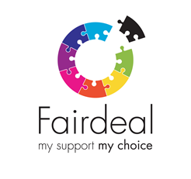 | Fair deal want to give you the best service.
 | We do everything we can to make sure our service is always the best it can be.
 | If people tell us they are happy with their service then we know we are giving them the service they want or even better.
 | When people tell others about how good their service is, this is good for Fair Deal.
5 | We have a quality system which has 5 goals:
 | 1. We try to make sure that someone’s services are right from the very beginning.
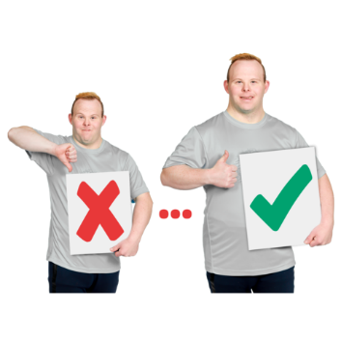 | 2. We are always trying to make your service even better.
 | 3. We make sure we have good relationships with everyone we work with.
 | 4. We make sure all the staff want to give the best service they can.
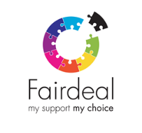 | 5. We make sure that Fair Deal’s business is always getting better.
 | To make sure we are the best we can be, we have some rules we follow.
 | - We listen to what people say they need and work out how we can try to provide that.
 | - Our managers are always trying to make all our services even better.
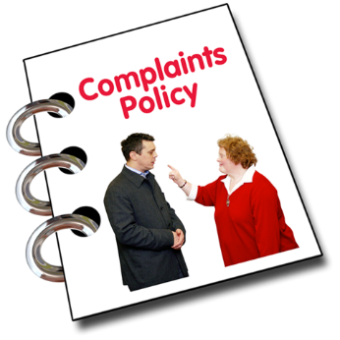 | - We try to make sure it is easy to report a problem and that it is sorted out very quickly.
 | - We make sure all staff have all the training and support they need to give you the best service possible.
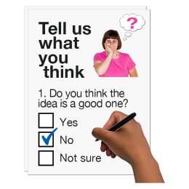 | - We make sure everyone who is involved with Fair Deal can have a say about our service. This could be inviting you to events or asking you questions.
 | - By planning everything carefully, Fair Deal make sure you get the best value for your money.
 | - We look at our policies and our service at least every year, which helps us to improve it.
 | - Different managers are in charge of different services but they make sure everyone has read and understood this policy.
 | - Every member of staff must be the best they can be and share any ideas about how to make our service even better.
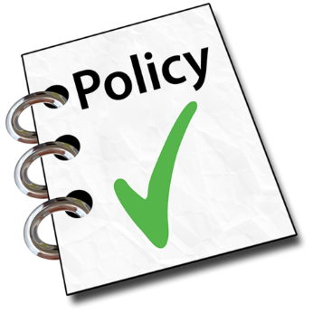 | - This document will be displayed in Fair Deal offices and copies are available for anyone who would like one.
 | - If there are any changes at Fair Deal or in the law then this policy will be up-dated
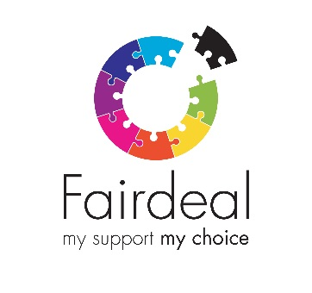 | If you have any questions about this document please speak to a staff member of Fair Deal.
Anne Marie Borthwick
Quality and Development Manager
Sept 2017

